NOTICE OF JOINT REVIEW BOARD MEETING
CITY OF NORTH CHICAGO
DOWNTOWN TIF

Notice is hereby given to all interested parties that the City of North Chicago, Downtown Tax Increment Financing District, Joint Review Board Annual Meeting will be held on Friday, June 25, 2021 at 2:00 p.m. via Zoom meeting link https://us02web.zoom.us/j/3969911446
Meeting ID: 396 991 1446
Passcode: 900362
Dial by your location
+1 312 626 6799 US (Chicago)
+1 301 715 8592 US (Washington DC)
+1 929 205 6099 U (New York)
+1 346 248 7799 US (Houston)
+1 669 900 6833 US (San Jose)
+1 253 215 8782 US (Tacoma)
Meeting ID: 396 991 1446 Passcode: 900362
Find your local number: https://us02web.zoom.us/u/kBY5IBZod
Said Meeting will be open to the public, and a copy of the agenda is attached.

CITY OF NORTH CHICAGO

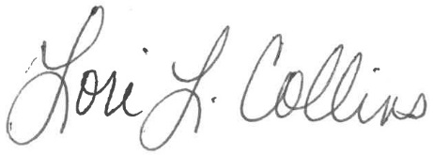
Lori Collins, City Clerk

AGENDA

CITY OF NORTH CHICAGO
DOWNTOWN TIF

JOINT REVIEW BOARD MEETING
Thursday, June 25, 2021
via Zoom meeting link
https://us02web.zoom.us/j/3969911446
2:00 p.m.

- Call Meeting to Order
- Roll Call of Joint Review Board Members
Member Representative / Signature
Lake County __________________________
Waukegan Township __________________________
Shields Township __________________________
North Chicago Community Unit School District 187 __________________________
College of Lake County - Community College District 532 __________________________
Foss Park District __________________________
City of North Chicago __________________________
Public Member __________________________
- Approval of Meeting Minutes of October 9, 2020
- Overview of Annual Financial Report for FY2020 City of North Chicago
- Overview of Project Activity City of North Chicago
- Joint Review Board Discussion
- Adjournment

